CHAPTER 2: Getting into genes

Worksheet 2.7

Pedigrees
Answers
1. Consider the following pedigree for three generations of a family. The shaded squares show those individuals who have inherited a particular trait or characteristic. The characteristic is not sex-linked.
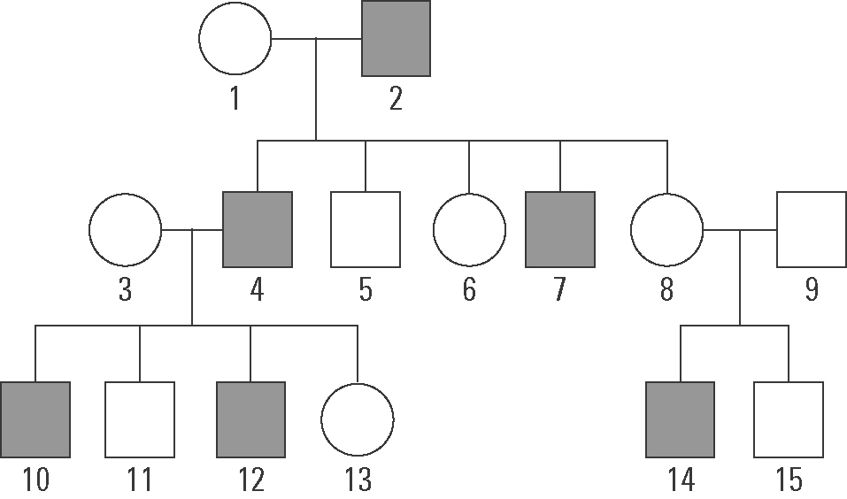 | (a) How is person 5 related to person 9?  Person 9 is the brother-in-law of person 5.  (b) What relation is person 8 to person 13?  Person 8 is the aunt of person 13.
(c) Is this trait dominant or recessive? Justify your answer.
Recessive. Individuals 8 and 9 do not have the characteristic, yet one of their children does. They must each have one copy of the allele for the condition but they are not displaying symptoms as the condition is recessive.

(d) Identify those who are definitely carriers of the gene for this trait but who are not affected.
1, 3, 8, 9

2. The following pedigree shows the inheritance of cystic fibrosis. The shaded individuals have the disease.
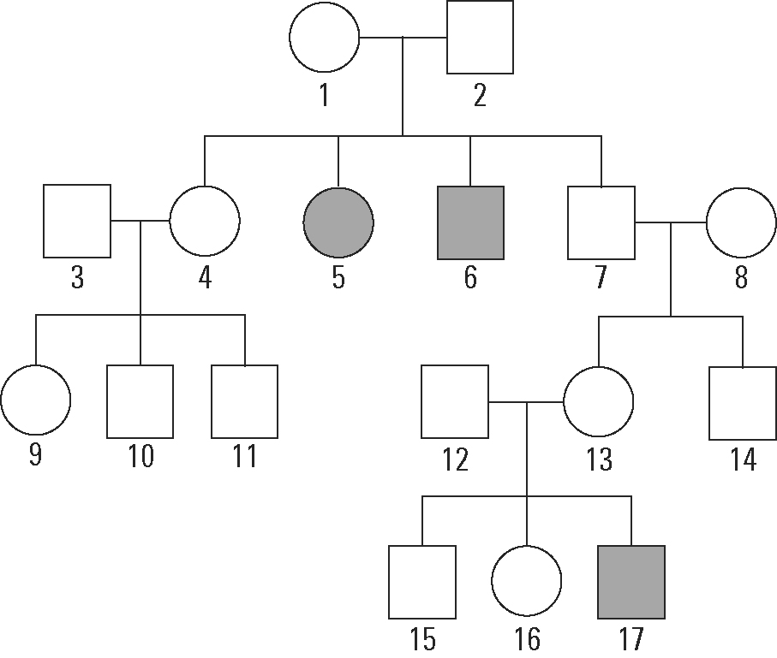 | (a) Is the gene for cystic fibrosis likely to be dominant or recessive based on this pedigree?  Recessive  (b) Some individuals are carriers of the gene but do not have the disease. Identify which individuals are carriers.  1, 2, 7, 12, 13
(c) If individuals 12 and 13 have more children, what is the chance that any future child will have cystic fibrosis? Justify your answer.
12 and 13 are both carriers. They are heterozygous. Thus there is 1 chance in 4 that any future child will have cystic fibrosis.

